Abdullah Asif

Introduction
This report evaluates the performance of Artificial Neural Networks (ANNs) implemented on two datasets: Msps and Gsps. The models were trained to assess their accuracy and loss on training, validation, and test sets. The Msps dataset was trained for 350 epochs, while the Gsps dataset was trained for 300 epochs. Performance metrics, including accuracy and loss, are analyzed to provide insights into model effectiveness.

Msps Dataset
The ANN model for the Msps dataset was trained for 350 epochs. Key performance metrics are as follows:
- Epoch 350/350:
  - Training Loss: 1.1754
  - Training Accuracy: 0.5188
  - Validation Loss: 1.2883
  - Validation Accuracy: 0.5417
- Test Accuracy: 0.4867

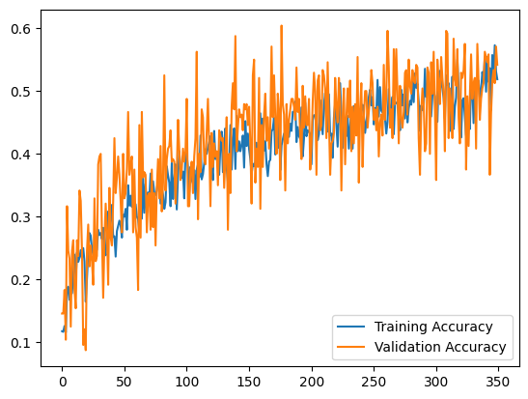

Gsps Dataset
The ANN model for the Gsps dataset was trained for 300 epochs. The performance metrics are summarized below:
- Epoch 300/300:
  - Training Loss: 2.3012
  - Training Accuracy: 0.0927
  - Validation Loss: 2.3101
  - Validation Accuracy: 0.0875
